Nine Warning Signs of Burnout
Burnout mostly happens to strong, smart, committed people who keep powering through until they can’t anymore. We don’t want any one getting to that point. Below are nine common warning signs of burnout and what to do when you notice them in yourself. Ignore these at your peril!
Warning Signs | What to do
When every curveball is a major crisis. Something is wrong when even small issues produce a strong emotional reaction. When you are depleted by burnout you don’t have the mental or physical resources to distinguish between a small problem and a big crisis. | If something comes up that you would ordinarily be able to handle but it seems insurmountable, talk to a trusted friend about how you are doing. Have them help you sort through the many factors that are contributing to your burnout. Identify the top two or three and find ways to made changes that will make your life better.
Chronic low energy and exhaustion. Exhaustion is one of the three big dimensions of burnout (Leiter & Maslach, 2005). The exhaustion associated with burnout is on a different level than just feeling tired here and there. It’s a chronic state of feeling overwhelmed and maxed out. | Being tired when you are short on sleep is one thing. Being tired and feeling overwhelmed and maxed out is an early warning sign of burnout. Let your manager know! Work out how much time you can sustain things (should be no more than a week or two) before you need to take a break to recharge.
Getting sick more frequently. The stress and adrenaline may keep you going for a while, but once that high wears off, your body crashes. The result is that your immune system breaks down and that makes you more susceptible to getting sick. “Sick” could be anything from colds and flu to severe headaches, stomachaches, and heart palpitations. | The body can be a good source of information on your levels of stress and burnout. Take some time on a regular basis to do a body scan. How much tension are you carrying? Where is it showing up? Is there something new happening that you should be paying attention to?
Not recharging or relaxing. Recovery is an important component of the burnout prevention process, yet taking a break has been stigmatized in work cultures. Studies place importance on two types of recovery: (1) how you recharge each day while you’re at work; and (2) what you do to recharge after work each night, on the weekends, and on vacation. | We need to collectively make sure we encourage breaks. Asking co-workers what they are doing to relax after work or on the weekend can start to normalize taking time to relax. We are people, not widgets. We need down time.
Having a sense of inefficacy. Inefficacy is feeling like you can’t produce results in your life. When you lose efficacy, your confidence plummets, you feel less effective at work and your self-worth may even be impacted. This the second of the three big dimensions of burnout. | This is not an early warning sign. This is a late warning sign. If you’ve reached this point, reach out to a trusted friend and talk through how to move forward given that you are now showing serious signs of burnout.
Feeling disengaged and being consistently checked out. Burnout is a process of unplugging from those things that give you energy and enthusiasm at work. The opposite state is work engagement, which is a potent blend of energy and commitment. | How excited are you to come to work? If it’s a chore to drag yourself to work, something is wrong. Have a conversation with your manager about what would excite you about coming to work. If you have too many things on your plate that you aren’t excited about, it’s time to make a change.
You find yourself being cynical and your enthusiasm for your work has faded and now everything and everyone rubs you the wrong way. This the third of the three big dimensions of burnout.  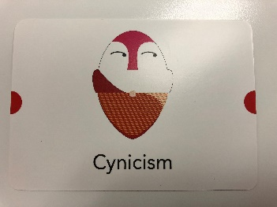 | Cynicism about a situation is frequently a sign that you’ve been disappointed by a similar situation in the past. If your manager isn’t able to help you resolve a situation, reach out to HR. Keep trying until you find a way to resolve the situation.  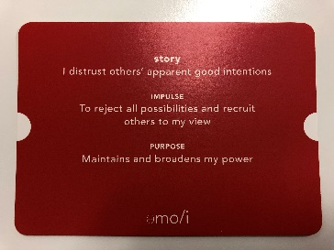
Can’t let go of perfection. Research shows that perfectionistic tendencies are associated with a higher risk of burnout because perfectionist behavior patterns drain your energy (Aydemir & Icelli). While some professionals don’t have a lot of room for error (think surgeons, air traffic controllers, and lawyers), the key is to ask yourself whether perfection is necessary for this specific project. More often than not, the answer is no. | If you are a certified perfectionist and you know it’s causing you undue stress, find a perfectionist “buddy” who can “catch” you in your perfectionism and offer insights into how to be an “excellence-ist” instead.
Too many Job Demands and not enough Job Resources. “Job Demands” are any aspect of your job that requires sustained effort or energy. Job Demands in and of themselves are not necessarily bad, but because they deplete your energy, you have to mitigate their impact with Job Resources. “Job Resources” are those aspects of your job that are motivating and help you achieve your goals (Bakker, Demerouti, Sanz-Vergel, 2014). | If you have a day in which you are mostly working on the parts of your job you only tolerate, build in more breaks and find a way to reward yourself with tasks you enjoy sprinkled through the day. On the other hand it that’s a normal day, it’s time to rethink the role you are in. That should not be your norm. We don’t need to have 100% of our role be things we enjoy but if its almost 100% things you only tolerate, then it’s time to make a change.

Remember, everyone is different. What are YOUR warning signs? Identifying the warning signs early is better for you and everyone else

